Chem 11500 In Class Problems
10/24/08

- The following compound, melamine, was implicated in a pet food contamination catastrophe that took place last spring.

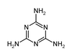

Answer the following questions about melamine.

- How many carbon atoms does this molecule contain?
- What functional groups are present?
- Can a resonance structure for this molecule be drawn? If yes, then draw it.

- Which compound has a higher lattice energy between LiCl and CsCl and why?

- LiCl because is more soluble than CsCl.
- LiCl because Li has a smaller ionic charge than Cs.
- LiCl because has smaller internuclear distance
- CsCl because has a smaller internuclear distance
- CsCl because Cs has a smaller first ionization energy.

- What is the formula for the following structure?

4. What are the O-N-O bond angles in the NO₃⁻ ion?

a. All equal 120º.
b. All equal 109.5º.
c. All are greater than 120º.
d. Two are greater than 120º one is less than 120º.
e. Two are less than 120º one is greater than 120º.

5. Write the electron configurations for Fe, Fe⁺² and Fe⁺³.

6. Use this graph to answer the following questions

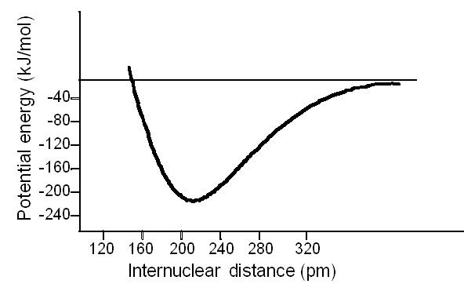

A. What information can be extracted from this graph?
B. Describe the forces between the particles between 210-280 pm.
C. Describe the forces between the particles between 200-160 pm.

